UPCOMING EVENTS, ACTIVITIES AND SPECIAL ANNOUNCEMENTS

Building Our Spiritual Community

Friday, October 20 – 1 Heshvan – Rosh Hodesh Mar-Heshvan
5:55 PM - Candle Lighting
6 PM - Minha/Kabbalat Shabbat/Ma’ariv
7 PM - Congregational Oneg Shabbat

Saturday, October 21 – 1 Heshvan – Rosh Hodesh Mar-Heshvan
9:30 AM - Kol Tefilah – Morning Service
Bat Mitzvah: Sophie Sussman, daughter of Alison & Lee Sussman
10:45 AM - Parashat Hashavua – Adult Torah Study
10:45 AM - Paper Clips Shabbat Service
5:55 PM - Minha/Seudah Shlishit/Ma’ariv/Havdalah
6:52 PM - Shabbat ends

New Procedures for the Mi Shebeirach List
In an effort to better serve the needs of our congregation, we are changing the way we maintain and update our Mi Shebeirach list (the list of people who have requested prayers for healing). To make sure our list is as current as possible, we are building a new list from scratch. So even if you have previously asked that a name be placed on this list, we ask that you call or email and request that person’s name be included on the list. Moving forward, names will be kept on the list for four weeks and then removed unless you, or a member of our Clergy team specifically request that they remain longer.
To have a name added to the list or to update the status of the person named, please call or email Laurie Albert in the Clergy office at 610-667-5000 x111 or lalbert@harziontemple.org.
﻿

Senior Rabbi Search Town Hall Meetings
The Senior Rabbi Search Committee invites you to join us for our Town Hall Meetings
Sunday, October 22 at 9:45 AM
(babysitting will be available for Sunday)
We strongly urge you to join us at one of these Town Hall Meetings.
Please come express your opinions and contribute your voice to the future of Har Zion!
RSVP is requested to hzt@harziontemple.org or call Harriet at 610-667-5000.

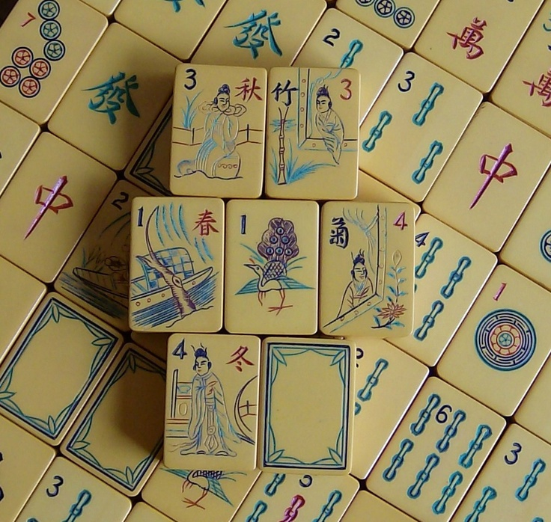
Mah Jong Mixer – Monday, October 23, 6:30 PM
Join the Sisterhood and HSA for a fun night of Mah Jong
6:30 PM Schmooze – 7:00 - 9:30 PM Mah Jong
All ability levels welcome! We will also teach you how to play. Open to all and snacks will be provided. ($10 fee charged if you need a card)
RSVP requested. Questions, please contact Susan Kochman (sbkochman@aol.com) or Elana Weinstein (elanaw@gmail.com)
Sponsored by the Sisterhood and NCCECE HSA

Torah Tuesdays with Hazzan Vogel
Tuesdays, October 24, 31; November 7, 14, 21, 28; December 5, 12 – 10 AM-11 AM
Learn to read Torah in nine sessions. This class will emphasize becoming proficient with Torah trope. Online audio visual aids will be used to reinforce in-class learning. The goal of this class is for each participant to independently prepare and read one Torah portion in a synagogue service.
Experience the Joys of Yiddish with Gerry Spector
Tuesdays, October 24 and November 7, 21 – 10 AM and 5 PM
Do you love Yiddish language, literature, poetry, song, theater, or cinema? Then this is the class for you!

Learning our Liturgy with Dr. Sara H. Cohen
Wednesdays, October 25; November 1, 8, 15, 22, 29 – 10:30-11:30 AM
A comprehensive study of our liturgy, using the Siddur (Jewish prayer book), as our text. We will explore the history, origins, authors, structures and meaning of our prayers from Biblical times to the present. This “virtual tour of Judaism” will enlighten us, enable us to relate more fully to our prayers and make our attendance at worship services more meaningful and enjoyable.

Wednesday Class Night
October 25; November 8, 29; December 13
Nosh and Schmooze 7 PM, Classes start 7:30 PM
Jam Session with Rabbi Allen
Har Zion is getting the band back together! Rabbi Allen is looking for musicians for a jam session. All levels of experience are welcome! Bring your instrument, your voice and your spirit of improvisation!
Balancing Justice and Forgiveness: Some Biblical Insights with Emilie S. Passow, Ph.D.
What is Justice? When does it leave room for forgiveness? These are complex questions on both a personal and a societal level. By analyzing some key Biblical narratives ranging from the Garden of Eden through Moses’ career, along with some classical and contemporary rabbinic commentaries, this series will explore Jewish perspectives on these ongoing issues.
Jewish Music and Prayer: Where have we come from and where are we going? with Hazzan Vogel
Tracing the last one hundred years of musical practice in the synagogue this class will examine the ever-evolving modes and styles of prayer from the beginning of the 20th century through the present time. Through discussion about the meaning of the prayers as well as active listening, participants will be encouraged to think critically about the musical aspects of prayer and how various melodic styles and genres work to enhance the spiritual experience.

Rabbi Shawn and the Philosopher’s Stone
Thursdays, 11 AM-Noon
Abraham Joshua Heschel – October 26, November 2
Martin Buber – November 9, 16, 30
David Hartman – December 7, 14, 21
Join Rabbi Shawn as we explore modern Jewish philosophy – without getting too academic (that will be the alchemy involved).

Popular Commentaries on Genesis with Rabbi Rosenberg
Thursday mornings, 10 AM – October 27 class is cancelled
We will study the commentaries found in the Hertz Chumash, the Etz Hayim Chumash, and the commentaries of modern biblical scholars to deepen our understanding of the first book of the Bible.

Sunday, October 29 starting at 2 PM

First, they wanted your cereal…Now, they want your basketballs! And bats! And rackets! And helmets! And gloves, etc.
Norman and Rabbi Shawn are collecting gently used sports equipment.
They will come to your house to pick it up!
Email Norman, neinhorn@harziontemple.org or call 610-667-5000 to schedule your pick-up!
Support Har Zion's Tikkun Olam!
Donations benefit Leveling the Playing Field.
Leveling the Playing Field gives underprivileged children the opportunity to enjoy the mental and physical benefits of youth sports participation. This is accomplished through the donation of used and excess sporting equipment to programs and schools serving low-income communities.
Live Performance of
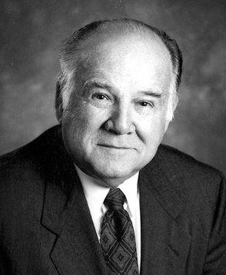
Heir To My Estate: The Afterlife of My Father, Rabbi Gerald Wolpe
Tuesday, October 31, 7 PM
Written and Directed by Daniel M. Wolpe
Starring Daniel M. Wolpe and Barry Pogach
81 year-old Rabbi Gerald Wolpe dies and is reunited with his father Benjamin Wolpe, who passed away when Jerry was 11 and Ben was 46. Their reunion opens old wounds and allows them both to finally heal.
Cost: $5
Please drop off your check at the office or purchase your tickets in advance online.
(A small service fee will be charged for online reservations.)

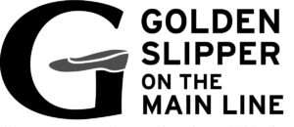
Highlighting New Afternoon Classes…
Bring a dairy lunch to eat before class
The Birth of Israel: Four Approaches
with Dr. Ely Levine, PhD Bible, Villanova University
4 Mondays, October 30; November 6, 20 and 27 – 12:30-1:30 PM
Course Fee: $30
Adath Israel, 250 N. Highland Avenue in Merion Station, PA

The Exodus from Egypt is the founding story of the people of Israel. The rich text of Exodus 1-15, familiar from Cecil B. DeMille’s The Ten Commandments, can be examined from different perspectives. Each of these seeks information from the details, resolving difficulties in the text and adding layers of meaning. In four sessions, we will understand why the text is written the way it is, what may have happened and how we learn about that, and the implication for Israelite and later Jewish tradition.

Open A Book . . . Open Your Mind Fall Authors
Presented by the Sisterhood of Har Zion Temple and the Jane Fishman Grinberg Religious School
For more information about this and/or our spring lineup, openabook@harziontemple.org

Purchase tickets online, harziontemple.ticketleap.com

Wednesday, November 1, 7 PM
Francine Klagsbrun – Lioness: Golda Meir and the Nation of Israel
Admission: $18 in advance/$25 day of event

Wednesday, November 8, 11:30 AM
Susan A. Silver – Hot Pants in Hollywood

Join us for a Special Sisterhood Lunch
Admission is Free for HZT Sisterhood members/$18 non-Sisterhood members

Wednesday, December 6, 7 PM
Rabbi Daniel Cohen – What Will They Say About You When You Are Gone:
Creating a Life of Legacy
Admission: $18 in advance/$25 day of event
This event is brought to Har Zion Temple in collaboration with the Jewish Book Council.

Current Events with Norman Einhorn
Thursdays, November 2, 16; December 7, 11:30 AM-12:30 PM
At the home of Patty Grobman
Ripped from the day’s headlines, our multi-media classes revolve around issues that are making the news. Whether it’s Israeli or American politics, personalities or other pressing issues of the day, we’ve gotcha covered.

Do you need the Har Zion Temple Caring Connection?
Do you know about the Har Zion Temple Caring Connection? We are a community, a network of fellow
congregants who would like to hear from you if you have a need in your good times and bad. We encourage any congregant to contact us if you know of a fellow congregant who is ill or has had a loss. Please don’t assume we know. Please contact Laurie Albert, 610-667-5000, ext 111 or lalbert@harziontemple.org. Help us help you!

Sisterhood Floral Fund Donation Cards are available for acknowledging special birthdays, special events, happy occasions, new babies and wishes for a speedy recovery, as well as, memorializing loved ones. Contributions to the Floral Fund provide Bimah flowers throughout the year.
Four for $30 ($10 each) – To purchase your donation cards, please contact Michelle Strayer, 610-992-9371 or moibas83@hotmail.com.


Use the Sisterhood Scrip Program for All of Your Shopping Needs!
Stock up on gift cards from Scrip. A percentage of the money you spend on each card benefits the Sisterhood. Why not support Sisterhood while planning your shopping days? Order your Scrip cards and be prepared whenever you shop! Please contact Michele Perlstein, mshoueka@hotmail.com or 610-519-1211 for more information.



INNOVATION UPDATE FROM

Israeli Tech Helps Mexican Rescuers Locate Quake Victims
Radio-wave technology developed by Israeli firm Camero-Tech that can “see” through solid walls is helping rescue workers in Mexico search through rubble for buried victims. Amir Beeri, the CEO of the firm, said “We got reports from our representative in Mexico that our technology is being used there by the rescue workers and he sent us TV images that show our systems in use.”
The company’s “sense-through-the-wall” imaging technology uses radio waves to map the layout of areas that are blocked by bricks or any other material. The radio waves penetrate the rubble and get signals back from within. These signals are then analyzed by powerful algorithms which are able to detect in real time if there is movement or breathing within the destruction, indicating there is someone alive that needs to be rescued. The system also allows users to pinpoint the location of the person or people trapped within the building, even if they are unconscious, Beeri said. To read more, go to: http://www.israelideas.org/#!current/c1gqf.
Transportation to Har Zion Temple
“Oh, if I’d only known she/he needed a ride to Har Zion.”
“Oh, I would have been there but I couldn’t get a ride.”
We are hearing these statements more and more – and would like to help our congregants who would like to attend services, meetings and programs.
Do you need a ride…To Services? To daytime or evening meetings and/or programs?
Can you provide an occasional ride?
What areas would be convenient for you? What Services, meetings, or programs do you usually attend (morning/afternoon/evening)?
Please contact Nanci Goldman, NanciG22@aol.com or 610-664-7987.

Share Your Simha!
We encourage you to sponsor an Extended Kiddush to celebrate any special simha, such as an Anniversary of a Bar/Bat Mitzvah, Baby Naming, Aufruf, Birthday, Anniversary or Graduation, etc. You may also want to consider contributing to our Shabbat Fund in honor of your special occasion. For more information, please contact Executive Director Gavi Miller, ext 105 or gmiller@harziontemple.org.

Bimah Flowers Can Be Sponsored
Bimah flowers can be sponsored in honor of a special occasion such as a Bar/Bat Mitzvah, Anniversary or Special Birthday. Please contact Reisel Weinberger, risey@aol.com or 610-668-1148.

SHOP THE GIFT BOX FOR ALL GIFT-GIVING NEEDS!

SPECIAL – Embossed Graphics Sale – Buy One, Get One Free (of matching set)
Until October 30
Regular hours:
Monday – Thursday, 9:30 AM to 4 PM; Friday, 9:30 AM to 3 PM
Sunday, 9:30 AM to 12:30 PM (when school is in session)
Additional hours by appointment.
For info, please call 610-667-2698, or email giftbox@harziontemple.org.

Regular Daily Minyan
Evenings: 6 PM
Mornings: Sunday – 9 AM, Monday and Thursday – 6:50 AM, Tuesday, Wednesday, and Friday – 7 AM

Minyan Volunteers Needed
“The world stands on three things: on Torah, on prayer and on kindness to others.” – Pirkei Avot
Please register to be called if we need you for daily minyan. E-mail or call Laurie Albert, ext 111 or lalbert@harziontemple.org, with your name and cell phone number for a text.

